Unit 1 initial post 15. August .2023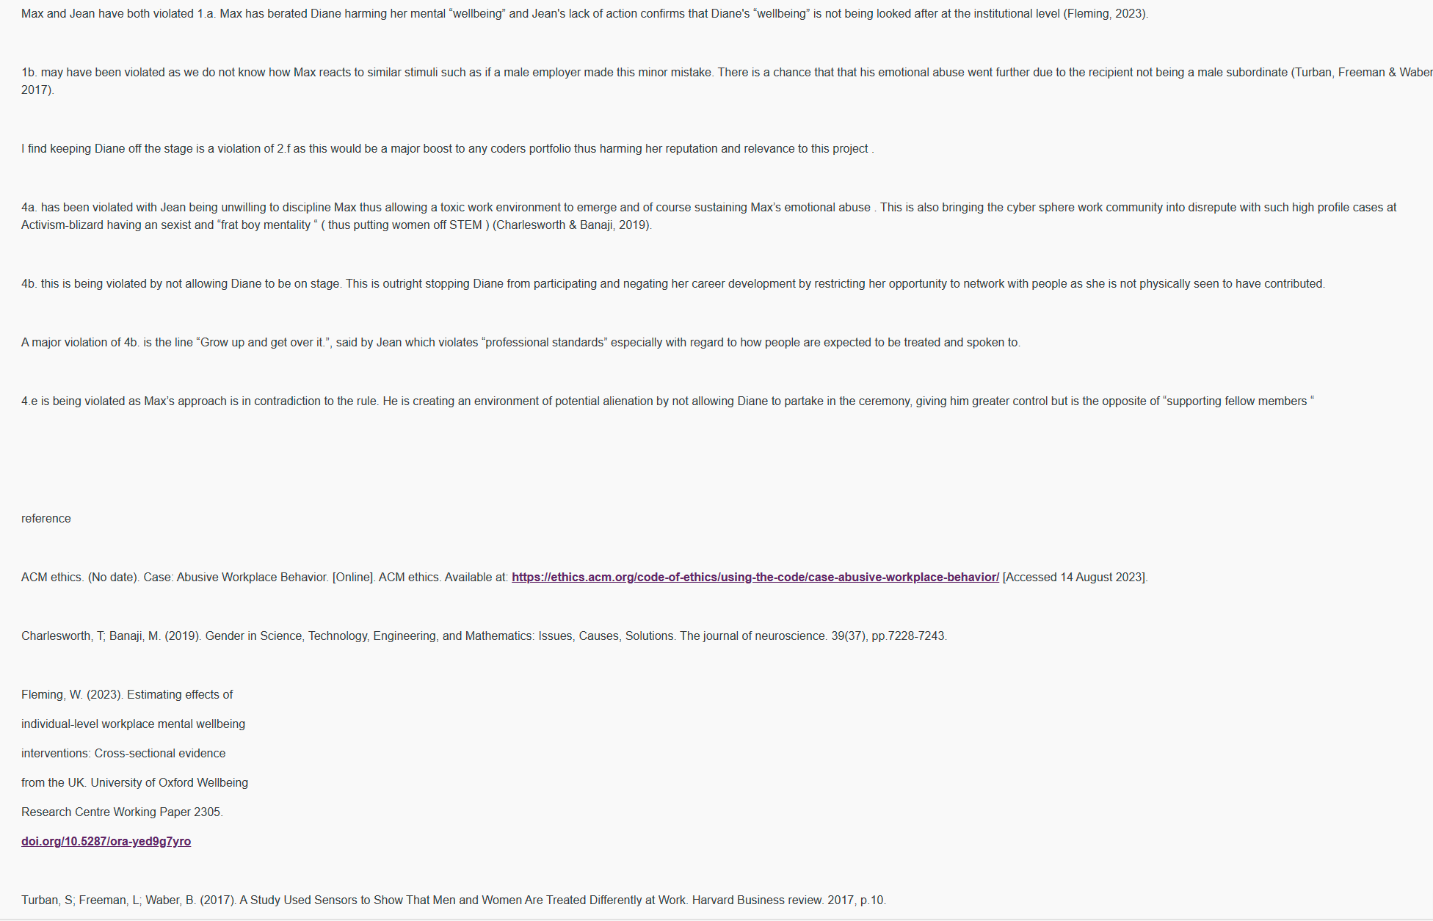

Unit 1 peer response
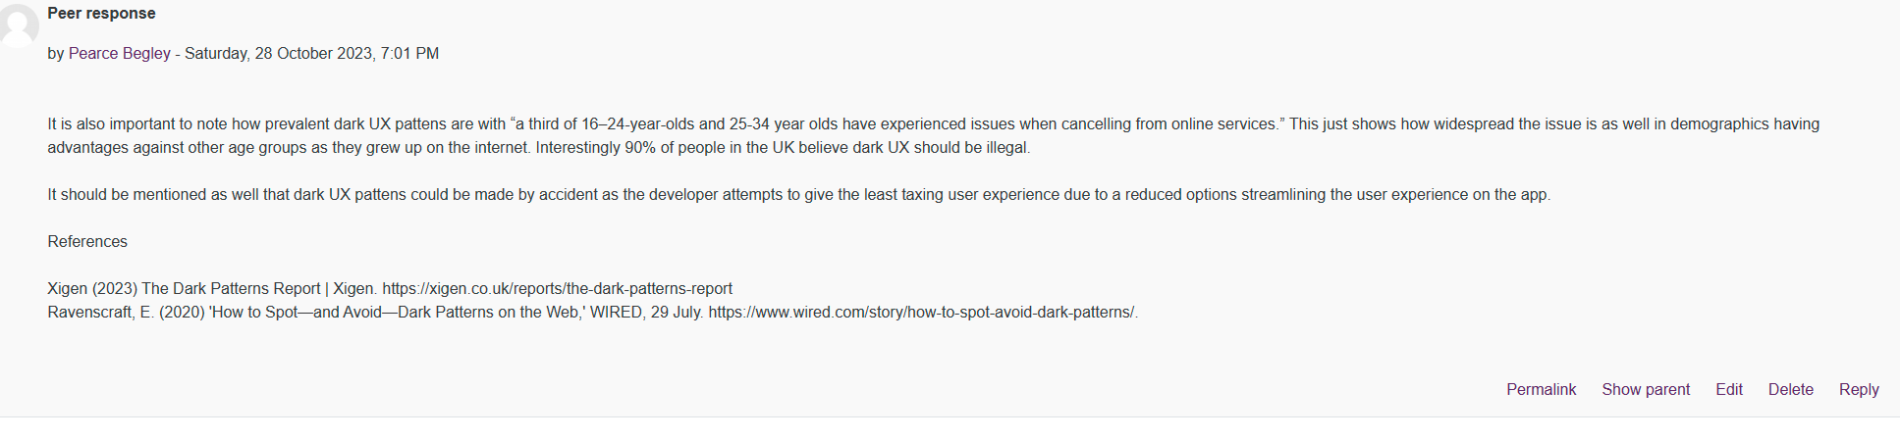
Self-reasoning quiz unit 1
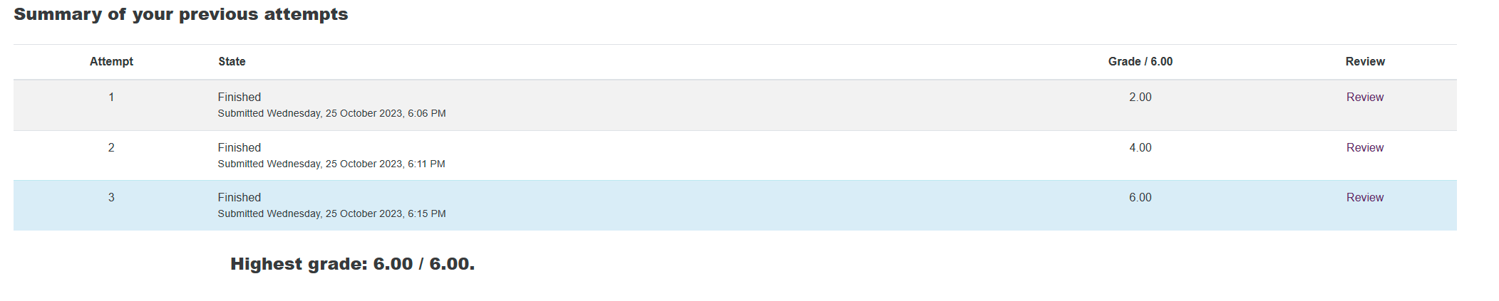

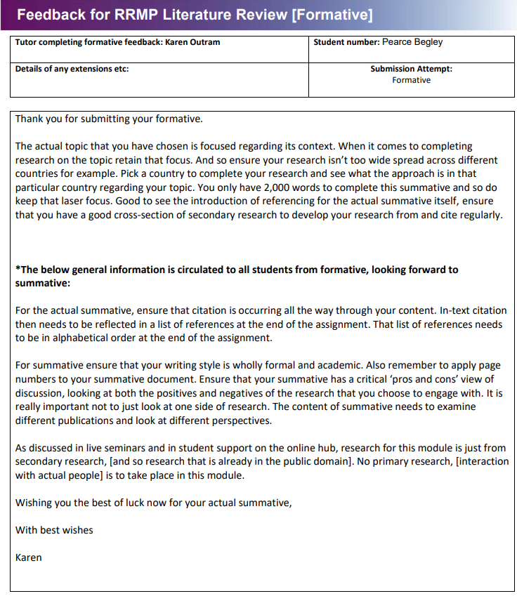
literature feedback unit 4

Intel post in collab discussion 2 unit 7
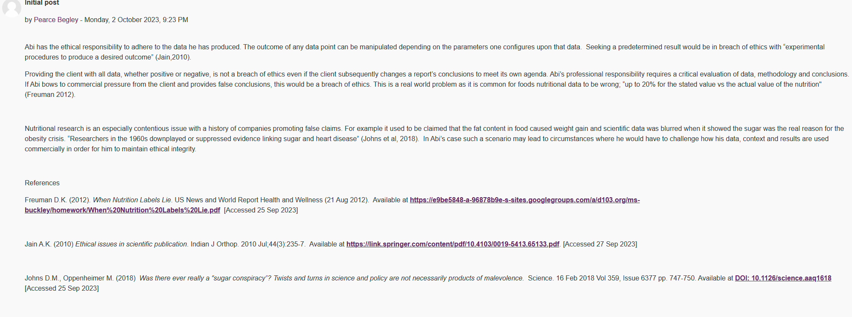

unit 7 peer response in collab discussion 2
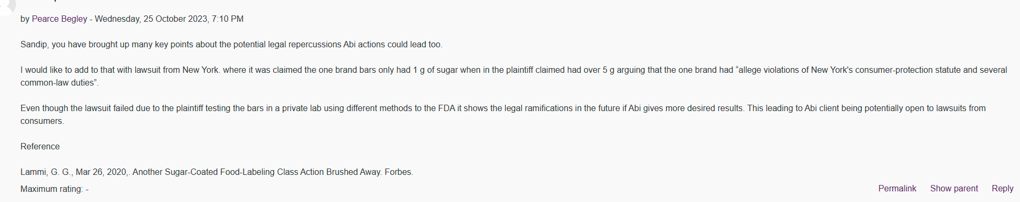
Unit 8 research presentation outline

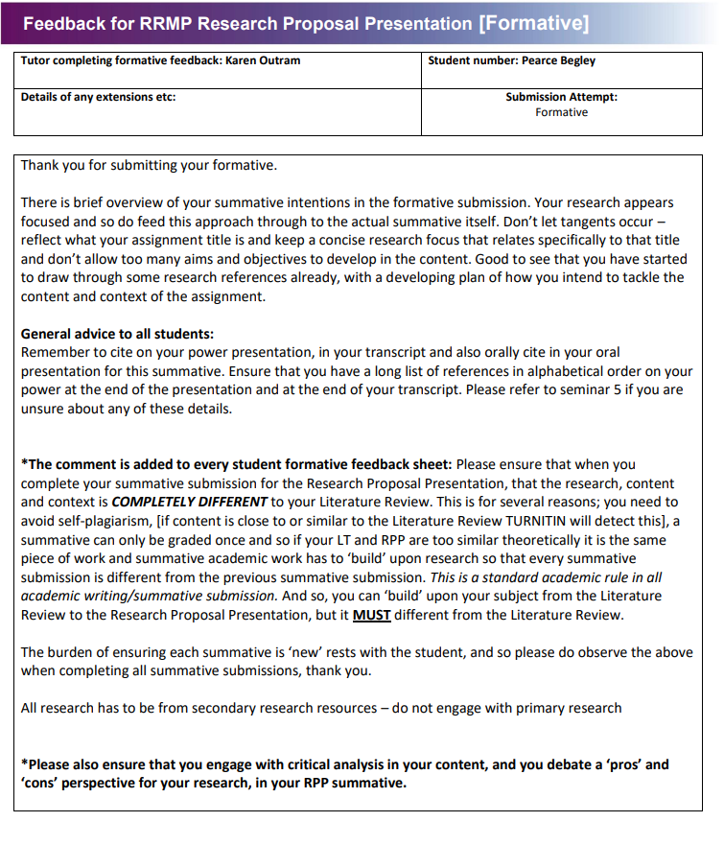
Unit 11 action plan
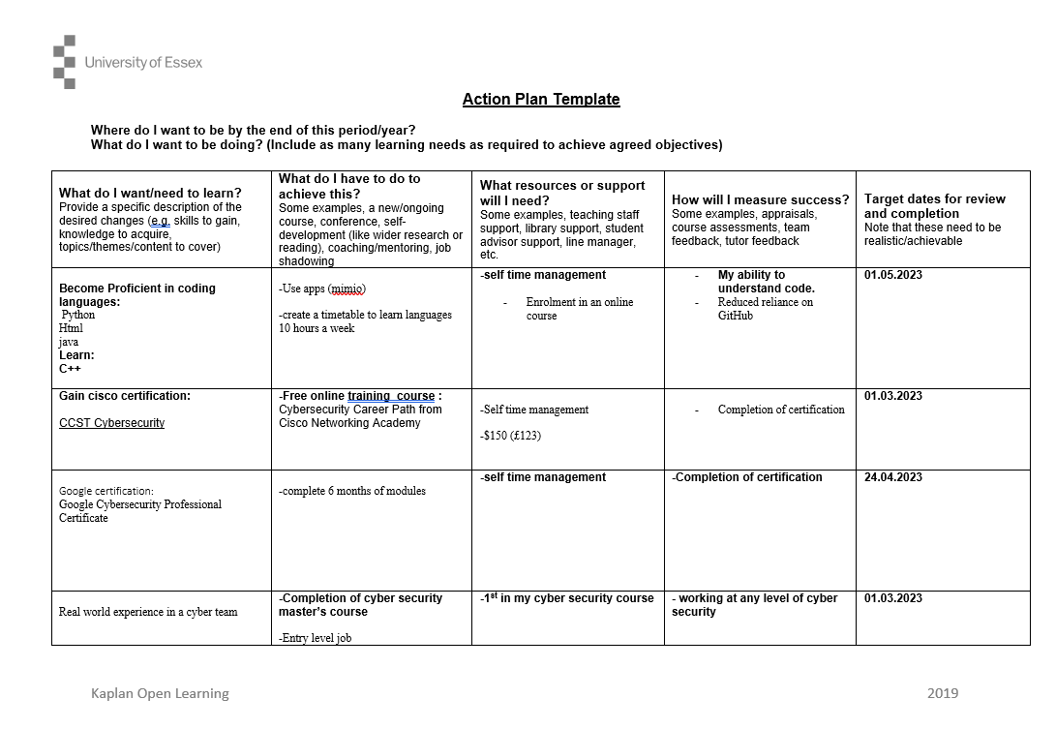

Unit 12 self test quiz
